HW11a - Lookup table buildout

Group 22

|  |  |
| --- | --- |
| Abhay Kurian | 001491312 |
| Smit Patil | 001378302 |
| Shivam Verma | 001344145 |
| Nikhil Kukreja | 001055376 |

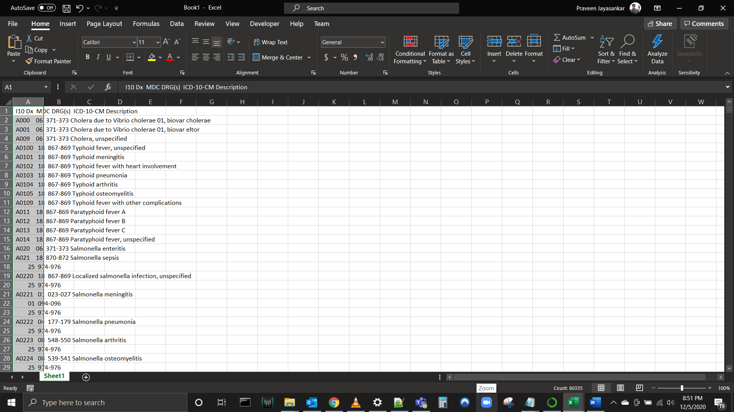

ADD AN EXTRA COLOUMN

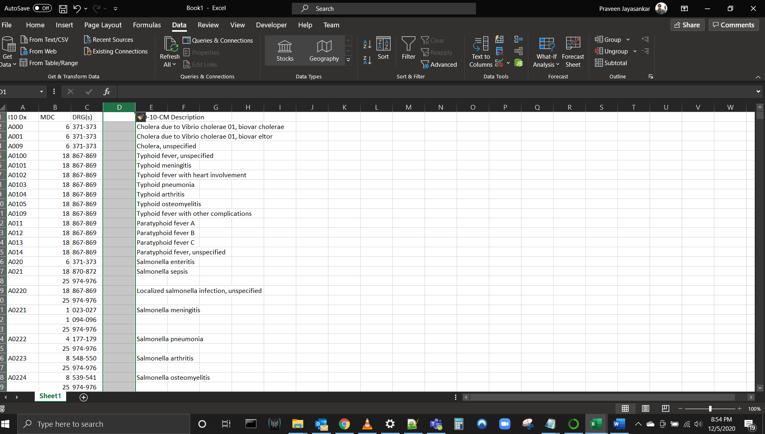

After splitting and getting the End Column, find the difference between the End value and Start value and if there is no end value fill the difference value with ‘0’ using the formula “=MAX(0,D2-C2)” and copy the formula to all the cells in Difference Column

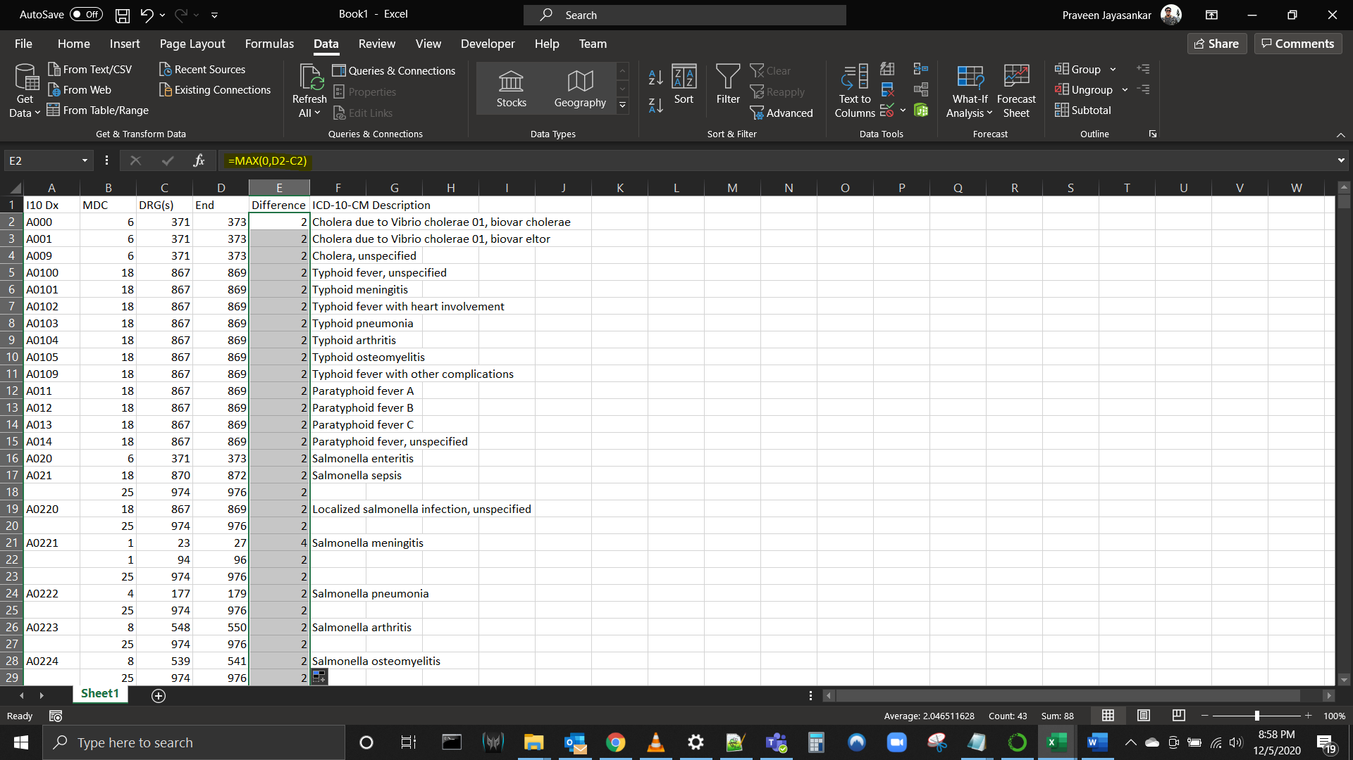

Code to insert the number of rows equal to the value in the values in Difference Column

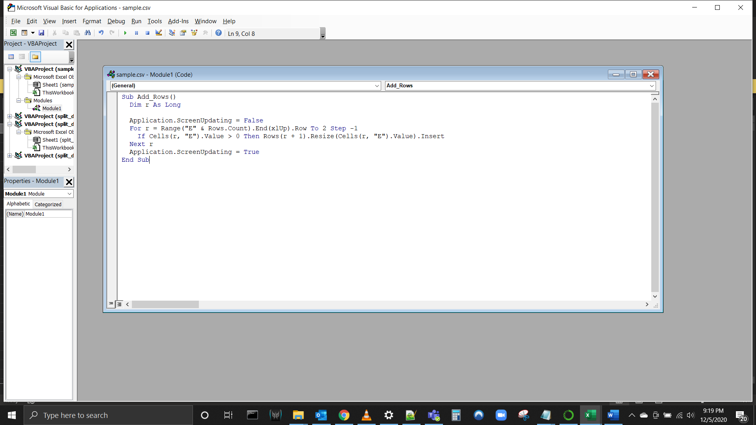

FINAL:

